**SALES DASHBOARD**

**MINOR PROJECT REPORT**

***Submitted by***

**PAYAL(22BCA10325) , JASHIKA(22BCA10175)**

***in partial fulfillment for the award of the degree of***

**BACHELOR OF COMPUTER APPLICATION**

**IN**

**UNIVERSITY INSTITUTE OF COMPUTING**



**Chandigarh University**

**(2025**

This project, titled **“Sales Dashboard in Excel,”** focuses on transforming raw sales data into an organized, visual, and interactive dashboard using the tools available within Microsoft Excel. In any business, analyzing sales data is crucial for understanding customer behavior, monitoring performance, and making informed decisions. However, when the data is large and unstructured, it becomes difficult to process manually.

**ABSTRACT**

To solve this problem, we used Excel to build a dashboard that summarizes key business insights such as **total sales**, **monthly trends**, **region-wise sales**, and **top-performing products**. The dashboard provides an **interactive interface** where users can apply filters and instantly see updated visuals and metrics, helping them make data-driven decisions without needing any coding or technical expertise.

Key Excel tools like **Pivot Tables**, **Pivot Charts**, **Slicers**, **Formulas**, and **Conditional Formatting** were used to create a professional and fully functional dashboard. These tools help in cleaning, organizing, and analyzing the sales data effectively.

The goal of this project is to demonstrate how Microsoft Excel, a widely accessible and user-friendly tool, can be used for **business intelligence and performance monitoring**. It helps save time, reduce manual effort, and present complex information in a clear, easy-to-understand way.

**INTRODUCTION**

This project is ideal for small businesses, managers, students, and analysts who want to track sales performance and gain quick insights without investing in expensive data analytics software.

In today’s digital and competitive business environment, **data plays a crucial role** in decision-making and strategic planning. Businesses generate large amounts of data daily, especially in the area of **sales and marketing**. Understanding this data is essential to track performance, identify growth opportunities, and improve overall efficiency. However, when the data is large and unorganized, it becomes very hard to analyze manually. This often leads to **delayed decisions, missed insights, and a lack of clarity** in business processes.

To address this problem, we have developed a project titled **“Sales Dashboard in Excel.”** This project uses Microsoft Excel to build a fully functional and **interactive sales dashboard** that transforms raw sales data into **meaningful visuals and summaries.** It is designed to provide a clear view of key metrics such as **total sales, monthly trends, top products, and region-wise performance.** The dashboard allows users to easily filter data using slicers, view interactive charts, and gain valuable insights without any need for coding or technical skills.

Using tools like **Pivot Tables, Pivot Charts, Slicers, Formulas, and Conditional Formatting**, the dashboard brings life to boring and complex data. It helps businesses and users:

* Monitor real-time performance
* Compare sales across different months or regions
* Discover top-selling products
* Make faster and more informed decisions

**TECHNIQUE USED**

The best part is that this dashboard is **easy to use, cost-effective**, and **built using a software (Excel)** that is already widely used in organizations. It demonstrates how powerful Excel can be as a data analysis and visualization tool.

This project is built entirely using **Microsoft Excel**, which is a powerful and widely-used spreadsheet software. Even though Excel is often seen as just a tool for creating tables or simple calculations, it offers a range of advanced features that allow users to perform **data analysis**, **visualization**, and even create **interactive dashboards**.

Below are the main technologies and tools used in the project:

**🟩 Microsoft Excel**

* The core platform used for building the dashboard.
* Used for data input, storage, analysis, and visual output—all in one file.

**🧮 Formulas and Functions**

* Excel functions like SUM, AVERAGE, OFFSET, VLOOKUP, TEXT, and RANK were used for calculations, formatting, and data manipulation.
* These functions help to automate data handling and reduce manual errors.

**📊 Pivot Tables**

* Used to summarize large sets of raw sales data into meaningful insights.
* Help in grouping, filtering, and comparing values such as total sales, product performance, and regional trends.

**📈 Pivot Charts**

* Provide graphical representations of the summarized data.
* Include column charts, line charts, pie charts, and bar charts to represent trends and comparisons clearly.

**🎛️ Slicers**

* Slicers are interactive filters that allow users to dynamically change the view of the dashboard by selecting specific months, regions, or product categories.
* They make the dashboard more interactive and user-friendly.

**SALES DASHBOARD DATA**

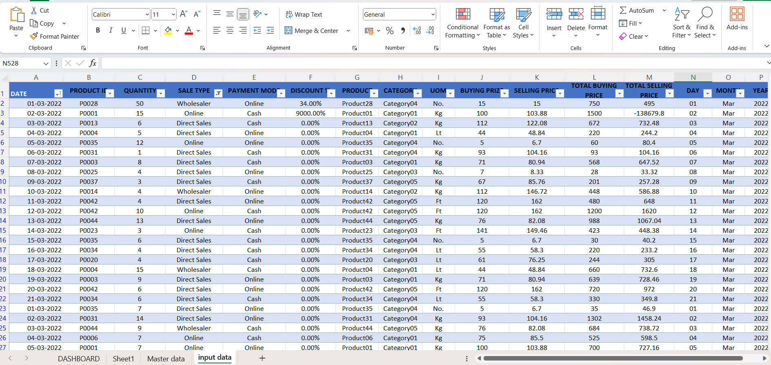

This project is created using Microsoft Excel without any programming. The Excel file itself acts as both the demo and the code.

**DEMO AND CODE**

🔹 Demo Features:

* View key sales info like Total Sales, Top Products, and Region-wise Performance.
* Use Slicers to filter data by Month, Region, or Product Category.
* Charts and metrics update instantly based on selections.
* Visual trends shown using Bar, Line, and Pie Charts.
* Conditional Formatting highlights top or low performers.

🔹 **Code Logic in Excel:**

* Formulas like SUM, IF, VLOOKUP, RANK,OFFSET used for calculations.
* Pivot Tables summarize large data into meaningful insights.
* Pivot Charts visualize sales trends and comparisons.
* Slicers act as filters to make the dashboard interactive.
* Data Cleaning Tools like Remove Duplicates, Text to Columns used to clean raw data.

**🔹 Structure:**

* Raw Data Sheet – Contains the original dataset.
* Pivot Table Sheet – Summarized data.
* Dashboard Sheet – Interactive visuals and metrics**.**

**DASHBOARD**

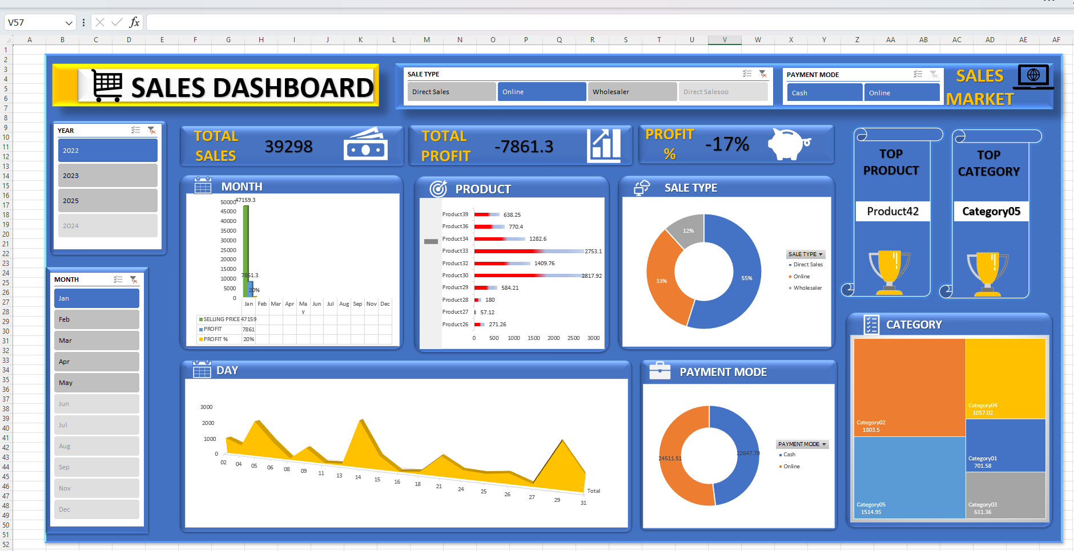

**CONCLUSION**

The Sales Dashboard in Excel project successfully demonstrates how powerful and insightful data analysis can be achieved using just Microsoft Excel. In today’s data-driven world, businesses need quick and clear insights to make smart decisions, and this dashboard provides exactly that—without requiring any programming skills or expensive analytics tools.

By using Excel's built-in features like Pivot Tables, Pivot Charts, Formulas, Slicers, and Conditional Formatting, we transformed plain, raw sales data into a dynamic, interactive, and professional dashboard. Users can filter data based on specific months, regions, or product categories and instantly view updated charts and metrics. This interactivity makes it much easier to understand trends, compare performance, and make data-backed decisions.

The project proves that Excel is more than just a spreadsheet tool—it can serve as a powerful platform for data visualization and business intelligence, especially for individuals and small businesses with limited resources.

Some key benefits highlighted through this project:

* ✅ Easy to use and requires no programming
* 📉 Time-saving and reduces manual errors
* 📊 Delivers clear and meaningful insights
* 💼 Cost-effective and widely accessible
* 🔄 Automatically updates based on filters and data changes

This dashboard can be further customized or scaled to suit different types of businesses and data sets. It serves as a practical, real-world example of how to convert raw data into valuable business tools using simple yet powerful Excel techniques.